13. React-HOL

BookDetails.js
import React from 'react';

const BookDetails = () => {
const books = [
{ id: 1, title: 'React in Action', author: 'Mark T.' },
{ id: 2, title: 'JavaScript: The Good Parts', author: 'Douglas Crockford' },
{ id: 3, title: 'Eloquent JavaScript', author: 'Marijn Haverbeke' }
];

return (
<div>
<h2>📚 Book Details</h2>
<ul>
{books.map(book => (
<li key={book.id}>{book.title} by {book.author}</li>
))}
</ul>
</div>
);
};

export default BookDetails;
BlogDetails.js:
import React from 'react';

const BlogDetails = () => {
const blogs = [
{ id: 1, title: 'Intro to React', writer: 'Alice' },
{ id: 2, title: 'Hooks in Depth', writer: 'Bob' }
];

return (
<div>
<h2> Blog Details</h2>
{blogs.map(blog => (
<div key={blog.id}>
<p><strong>{blog.title}</strong> - by {blog.writer}</p>
</div>
))}
</div>
);
};

export default BlogDetails;
CourseDetails.js
import React from 'react';

const CourseDetails = () => {
const courses = [
{ id: 1, name: 'React Basics', duration: '4 weeks' },
{ id: 2, name: 'Advanced React', duration: '6 weeks' }
];

return (
<div>
<h2> Course Details</h2>
<ul>
{courses.map(course => (
<li key={course.id}>{course.name} - {course.duration}</li>
))}
</ul>
</div>
);
};

export default CourseDetails;
App.js
import React, { useState } from 'react';
import BookDetails from './BookDetails';
import BlogDetails from './BlogDetails';
import CourseDetails from './CourseDetails';

function App() {
const [view, setView] = useState('book'); // book | blog | course
const [showCourses, setShowCourses] = useState(true);

// Using switch-case style function for conditional rendering
const renderComponent = () => {
switch (view) {
case 'book':
return <BookDetails />;
case 'blog':
return <BlogDetails />;
case 'course':
return <CourseDetails />;
default:
return <p>Select a view above</p>;
}
};

// Element variable style
let detailComponent;
if (view === 'book') {
detailComponent = <BookDetails />;
} else if (view === 'blog') {
detailComponent = <BlogDetails />;
} else if (view === 'course') {
detailComponent = <CourseDetails />;
}

return (
<div style={{ padding: '20px' }}>
<h1>Blogger App</h1>

{/* Buttons to change view */}
<button onClick={() => setView('book')}>Book Details</button>
<button onClick={() => setView('blog')}>Blog Details</button>
<button onClick={() => setView('course')}>Course Details</button>
<button onClick={() => setShowCourses(!showCourses)}>Toggle Courses</button>

<hr />

{/* 1. If-Else (via element variable) */}
<h3>Rendered via If-Else:</h3>
{detailComponent}

<hr />

{/* 2. Ternary Operator */}
<h3>Rendered via Ternary:</h3>
{view === 'book' ? <BookDetails /> : view === 'blog' ? <BlogDetails /> : <CourseDetails />}

<hr />

{/* 3. Short-circuit && */}
<h3>Rendered via && operator:</h3>
{showCourses && <CourseDetails />}

<hr />

{/* 4. Switch-case-like function */}
<h3>Rendered via Switch-style function:</h3>
{renderComponent()}
</div>
);
}

export default App;

OUTPUT:
Booking Details:
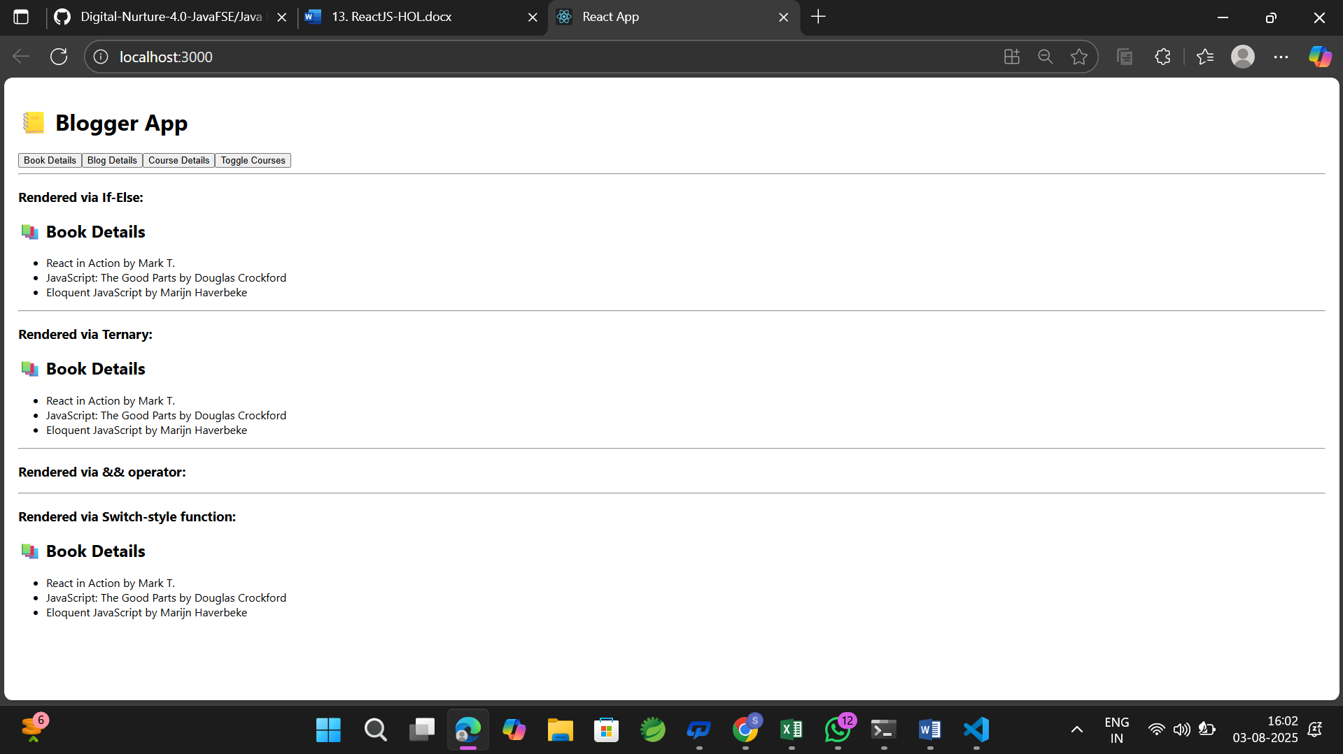
Blog Details:
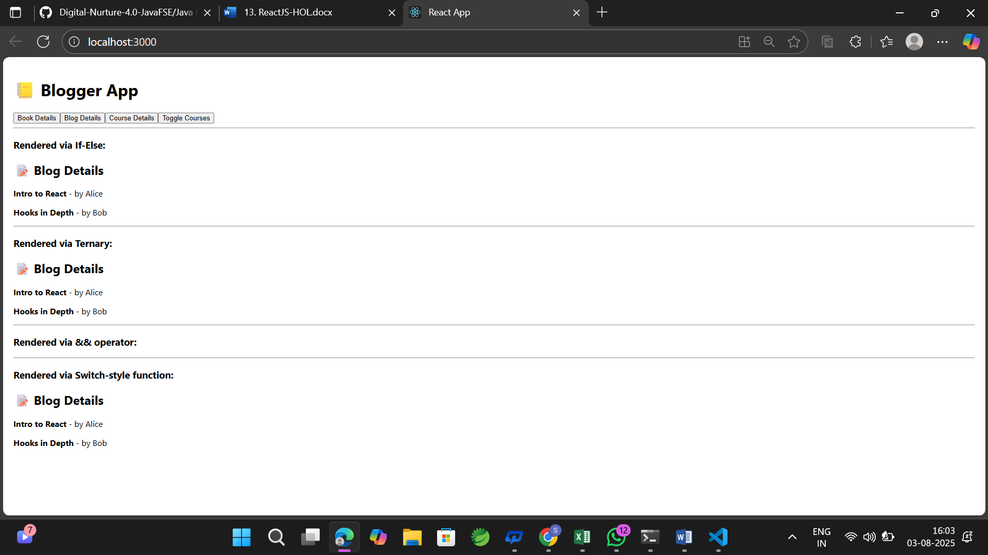

Course details:
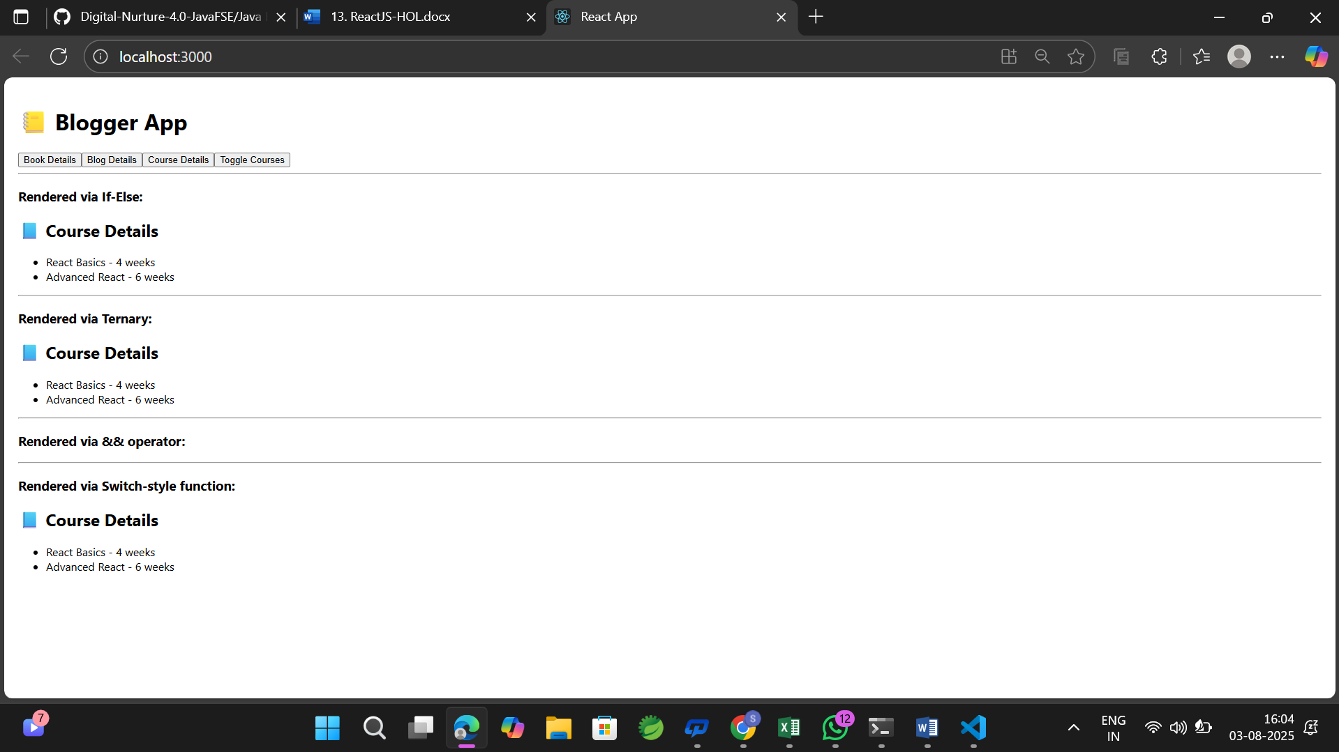
Toggle courses:
